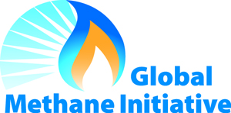

Global Methane Initiative
Coal Subcommittee Meeting Agenda
Palais des Nations, Geneva, Switzerland
24 September 2018

10:50 Welcome Addresses
Subcommittee Co-Chairs

11:00 Update from Administrative Support Group (ASG)
Monica Shimamura, ASG

11:30 Coffee/Tea Break

11:45 Subcommittee Report
Subcommittee Co-Chairs

12:00 Partner Country and Project Network Updates
Partner Country delegates and Project Network members
- Brief updates (max. 10 minutes) from Partner Country delegates and Project Network members regarding any new or planned activities in-country or in other Partner Countries

13:00 Lunch

15:00 Partner Country and Project Network Updates (continued)

15:45 Developing a Strategic Approach to Ventilation Air Methane (VAM)
Clark Talkington, Advanced Resources International

16:30 Coffee/Tea Break

16:45 International Experience with Policies that Support Abandoned Mine Methane (AMM)
Meredydd Evans, Pacific Northwest National Laboratory

17:15 Summary of Action Items/Remarks
Subcommittee Co-Chairs

17:30 Conclusion of Coal Subcommittee Meeting

